Amy Jeon

Period 7

Escape Characters in Java

The backslash denotes the escape character. If the backslash is added to a code, it means that the character directly following will be printed as is, without its special function or meaning expressed in the program.

The following are the escape characters in Java:

* \t Inserts a tab in the text at this point.
* \b Inserts a backspace in the text at this point.
* \n Inserts a newline in the text at this point.
* \r Inserts a carriage return in the text at this point.
* \f Inserts a formfeed in the text at this point.
* \' Inserts a single quote character in the text at this point.
* \" Inserts a double quote character in the text at this point.
* \\ Inserts a backslash character in the text at this point (through personal discovery: this means that in order to have a backslash show up in the output, there actually needs to be two backslashes--one to be the actual slash that appears, and the one previous to ensure it shows up as such and is not misinterpreted for its actual function)

ASCII Art

ASCII Art as applicable in our program is text based visual art. What this signifies is that pictures or images will be created through a combination of various text characters--in other words, those omnipresent “artistic” creations that particularly persistent Youtube users post in the comments section upon feeling especially inspired. The simplest include rabbits and owls, which I personally explored in my lab, and increase in intensity until something like this appears:

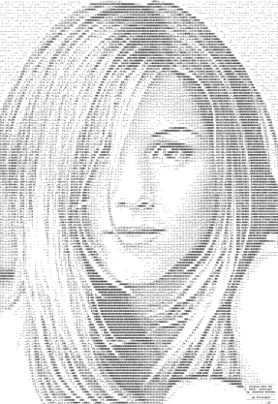 ← Someone really likes Jennifer Aniston!!

As stated--particularly inspired. There are various genres of ASCII Art, different eras, and numerous proponents of its usage, ranging from styles like “Amiga” or “Newskool” to “Block,” also known as “High ASCII”. Along with the advent of ASCII Art, there have also sprung up various programs and websites to aid in the creation of such art, among them chris.com or ascii-code.com, which appear readily in a simple google search. This demonstrates the inundation of ASCII Art within our modern technological society.